submission to manatŪ Taonga long term insights briefing

the components of an impactful and sustainable cultural sector into the future

November 2021

INTRODUCTION

SCREEN PRODUCTION AND DEVELOPMENT ASSOCIATION OF NEW ZEALAND (‘SPADA’)

THE NEW ZEALAND SCREEN SECTOR
The screen sector, perhaps more than most, connects with a wide variety of other sectors, such as travel, tourism, hospitality, building and construction, catering, and rental services, to name a few. As a result, it benefits a wide range of New Zealand businesses and individuals outside the sector. Equally, any downturn in the sector also affects these businesses. (2030 Screen Sector Strategy, August 2020)
The Aotearoa/New Zealand screen sector is an eco-system comprised of many dynamic parts. It includes the industries that produce, distribute, and monetise film and television content of all kinds for domestic and international audiences. It spans New Zealand producers and creatives responsible for development and production of original content for local and international audiences.
Screen Industry businesses generate $3.27bn gross revenue annually. Screen industry businesses include those involved in local film and television production, coproduction’s and internationally financed New Zealand-produced intellectual property; advertising and other types of productions; and those involved in exhibition, distribution, broadcasting, and servicing of international productions in New Zealand. The screen sector also creates digital exports: it converges with the gaming and interactive sector, visual effects, and animation among others. It is a broad and screen sector is emerging and must be embraced.
SPADA thanks Manatū Taonga Ministry for Culture and Heritage (MCH) for the opportunity to make a submission on the Long-Term Insights Briefing (LTIB). We look forward to sharing how the creative sectors can continue to contribute to the future economic and cultural wellbeing of Aotearoa.
SPADA, together with key industry organisations, took part in the joint WeCreate / Manatū Taonga online LTIB workshop session held in early November 2021; and SPADA also wholeheartedly supports the recommendations detailed in WeCreate’s LTIB submission delivered to Manatū Taonga.

existing strategy
As detailed in WeCreate’s submission, a range of forward-thinking strategic imperatives have been undertaken across the sector in recent years – after extensive consultation with key industry practitioners and stakeholders, which are yet to be actioned by government. Of note:
* In 2019’s “From the Knowledge Wave to the Digital Age”, government stated that it would partner with WeCreate on key recommendations in its Action Plan;
* Identified the Review of the Copyright Act and the 2030 Screen Sector Strategy (which has since incorporated a COVID-19 update, delivered in August 2020), as building blocks for a Creative Industries Transformation Plan.
Prior to an indefinite delay of the Creative Industries Transformation Plan in June 2020, government (via MBIE) began to engage with the work of the Interactive Aotearoa initiative, and this work continues.
WeCreate’s comprehensive two-year consultation process for its Action Plan identified seven enduring pillars (or components) required to grow the contribution of the sector to Aotearoa’s wellbeing, and these remain widely supported across the creative sector:
1 Connection & Collaboration
2 Measurement & Research
3 Regulation
4 Education
5 Skills, Talent & Capability
6 Capacity & Investment; and
7 Export.
These seven pillars are echoed and reflected in the outcomes of the Screen Sector Strategy 2030.

Screen Sector Strategy 2030
SPADA was an active member of the Facilitation Group of The Screen Sector Strategy 2030 (the ‘Strategy’), which was delivered to the government in August 2020. SPADA endorses the aims and objectives of the strategy including the desire to drive the following sections:
- Accelerate development and protection of home-grown IP for local and global audiences.
- Strengthen existing, and secure new, funding and investment.
- Work with the Government to modernise the regulation that shapes the sector.
- Identify and agree on a structure and establish a body for pan-sector representation (SPADA is a member of the SINZ Steering Group working on the establishment of the pan-sector body).

ALSO OF IMPORTANCE: The Living Standards Framework 2021
The Long-term Insights Briefings are part of a range of stewardship reports published by the Treasury; as well as the first Well Being Report – to be produced in 2022.
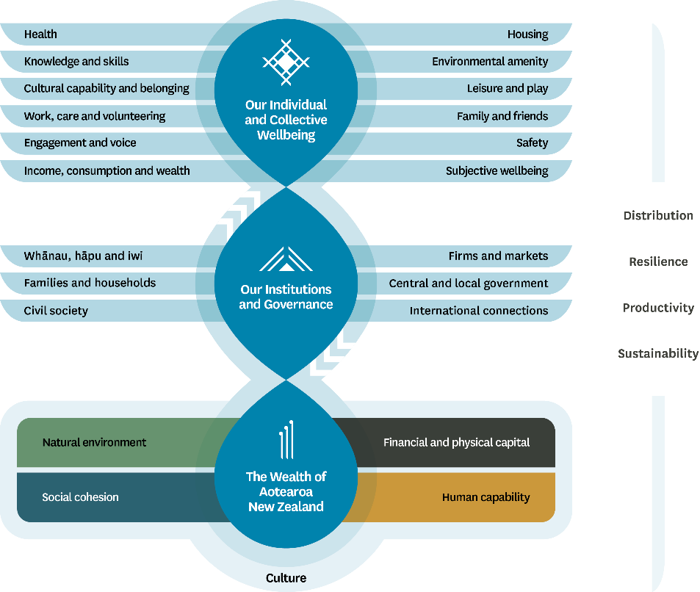
Culture as Capital
SPADA – and the screen sector - has long been engaged in the work to better articulate the ‘value’ of culture to government, and the wider economy. In George Barker’s book “Cultural Capital and Policy” (Centre for Law and Economics, ANU, 2000), he further defined the term “cultural capital”. Dr Barker’s analysis considers the role that cultural creation, and in particular film production, has in the formation of cultural capital, and makes some suggestions about ways of supporting this activity. His is an important contribution because it begins, without being reductive, to put an economic framework around what has previously been the realm of cultural theorists.
International and domestic research also illustrates the positive economic and societal impact culture has on wellbeing statistics - as well as deliver measurable outcomes economically. These in tandem, embeds value, encourages education, increases funding and promotes growth of cultural wealth amongst people and their communities.
Therefore, SPADA believes culture should be recognised within the Living Standards Framework (LSF) as one of the key , given the mutually beneficial outcomes of both the economic and wellbeing benefits of culture (in all its forms).
Therefore, SPADA proposes to Manatū Taonga that it consideration the positive benefits of recognising culture, in all its forms, as one of the key capital within the LSF.

Review of the Copyright Act
This review is ongoing, and once again SPADA is actively engaged in the consultation process. The act is central to the ability of copyright creators and owners to economically benefit from their content.
Without robust protections and the ability to challenge infringement of their works, creators could be stripped of their earnings and the ability to reinvest in future screen stories.

Reform of Vocational Education – Toi Mai
The Reform of Vocational Education and the Toi Mai Workforce Development Council (WDC) will be highly influential in determining learning pathways for the next 25 years in the cultural, creative, recreation and technology industries. SPADA worked hard to the relevant WDC had the appropriate screen sector representation, SPADA’s Executive Director is on the Board of Toi Mai.
The work through all of the WDCs will be industry led and the consultation that informs the Workforce Plans will need to directly align with the future planning work of this LTIB.

feedback

Components of Cultural System Infrastructure
What do you think about the infrastructure components we have listed? Are any components missing? Should any be removed?
SPADA supports the changes to the listed components as recommended by WeCreate in their submission. Reiterating that this infrastructure cannot function without better supported people who create and embody culture. We support strengthening and including more detail under the following components:
CONNECTION
- Recognition and understanding of the value and potential of our creative and cultural ecosystem, centralising mātauranga Māori
- Better cross government connection and responsiveness
- Aotearoa more connected to local and international markets, networks and infrastructure
- Enhancing New Zealand’s international reputation
EQUITY
- Driven by the communities it seeks to enable – at the head of the table
INVESTMENT
- Partnerships between government and private sector investment
- Investment in locally generated Intellectual Property (IP)
- “Business / Creative Professional” funding over “Project” funding
LEARNING PATHWAYS
- Broader focus on this title to better reflect sector needs – SKILLS, TALENT & CAPABILITY
- This will need to align directly with the work being undertaken by the Toi Mai WDC
- Despite employing approximately 130,000 New Zealanders, and international evidence supporting the growing importance of creative skills in the Future of Work, the sector is currently poorly represented in the government’s Future of Work Forum
SPADA would like to see the following components added:
VALUE
- Measurement of culture to show its inherent value – including the many sectors and sub sectors underneath the “Culture” banner
- Embedding economic and wellbeing value at the heart of all cultural activities
EDUCATION
- Educate people early. Discovering and nurturing creatives and creatives businesses of the future
- Skills and talent development. At all levels of education, early childhood, primary and secondary schools, school leavers, upskilling in sector, all the way to change of career
- Educate government, communities and individuals on the value of creativity and culture
LEGAL FRAMEWORK
- Better safeguarding, protecting and promoting the legal rights of creatives and creative businesses to earn from their work
- Clear, enforceable and accessible regulations
SUSTAINABILITY
- Weightless industries – cultural sector at the forefront of sustainability change
- Commitments to reducing carbon emissions
Which components do you consider to be most fundamental in fostering a sustainable and impactful cultural sector in the next 10-20 years?
The components are a sum, and depending on the outcomes we are seeking, they will need to be adjusted accordingly. SPADA points Manatū Taonga to the work already undertaken through the Screen Sector Strategy 2030 to best highlight the fundamentals in fostering a sustainable and impactful screen sector in the future.
SPADA endorses the aims and objectives of the strategy including the desire to drive the following sections:
- Accelerate development and protection of home-grown IP for local and global audiences
- Strengthen existing, and secure new, funding and investment
- Work with the Government to modernise the regulation that shapes the sector
- Identify and agree on a structure and establish a body for pan-sector representation
Full Screen Sector Strategy 2030 report found HERE
Please provide any additional feedback or ideas you have about the components of cultural sector infrastructure or the examples in the supporting material.
Ensuring that cultural sector workers and businesses are better classified and measured.
Screenwriters pay tax on the works they create, let’s consider the benefits of a joint IRD and Manatū Taonga collaboration to show the true economic contribution of the sector.

Future Lens
What do you think will act as significant drivers of change over time within the cultural sector?
Celebrating success is a key driver of change, this sits directly next to valuing the cultural sector. With the ability for the sectors and society to measure these successes through better collections of data and representation of culture in society.
Other key drivers of change:
- Technology – invention, adoption and access; the control of markets by multi-national Digital Service Providers, automation, Artificial Intelligence, and the value and security of data and IP assets
- Climate change
- Social and political upheavals
- Ongoing and future health needs
- Shifts in audience and market demand

How do you think these drivers of change could affect some of the components you've discussed?
In the time of Covid the cultural sector has proven its ability to adapt and change for growth. Ensuring that government (through a cross government approach) can match this flexibility, adaptability and better respond to rapidly evolving sector needs will become a major driver of many of these components.
Ensuring that Māori are centralised in all decisions of change and future planning. What is good for Māori is good for everyone.
What are the key risks, opportunities, and challenges when considering cultural system infrastructure to 2040?
SPADA supports the elements listed in the WeCreate submission.
RISKS
- Failure to celebrate the success and value of the sector; this debases and devalues the cultural sectors
- Unfair or exploitative rights agreements driven by old fashioned funding structures and international heavy weight pressure, international trade agreement concerns
OPPORTUNITIES
- Equitable profit share outcomes — including access to the New Zealand Screen Production Grant (NZSPG) for original authors for more than just feature films
- True commitment to consultation with screenwriters before funded development opportunities are designed
CHALLENGES
- Broad cross sector and cross government buy-in
- Shifts in viewership and market trends
- Capability building
- Environmental and health crisis
Please provide any additional feedback or ideas you may have about the future of cultural system infrastructure.
A true industry, societal and internationally recognised definition of the ‘cultural sector’ at the centre of the Manatū Taonga LTIB. This will knit together all of the industries, communities and elements of culture that make up the fabric of Aotearoa New Zealand.
Unfortunately, the prevalence of an attitude that the Manatū Taonga is not in sync with the screen sector means that an “us and them” perception stands in the way of meaningful connection between the sector and the Ministry that supports it. Compounded by feelings of creative individuals and businesses voices not being heard, a significant and unfortunate divide has been created. Covid has accelerated this for many individuals in the sector, shaped by funding opportunities offered during the Covid response.
SPADA would love to see this change: we want to see a maturing of the sector to work better together with Manatū Taonga to produce successful and fulfilling stories for Aotearoa’s screens and beyond.

Conclusion
SPADA is committed to ensuring that funding policies and processes prioritises support producer and production companies – which in turn supports the domestic screen production sector – which in turn supports positive changes for the future wellbeing of Aotearoa New Zealand.
Thank you again, and we look forward to the opportunity to continuing this important conversation with Manatū Taonga.

On behalf of SPADA,

Sandy Gildea
Executive Director
021 456 076

