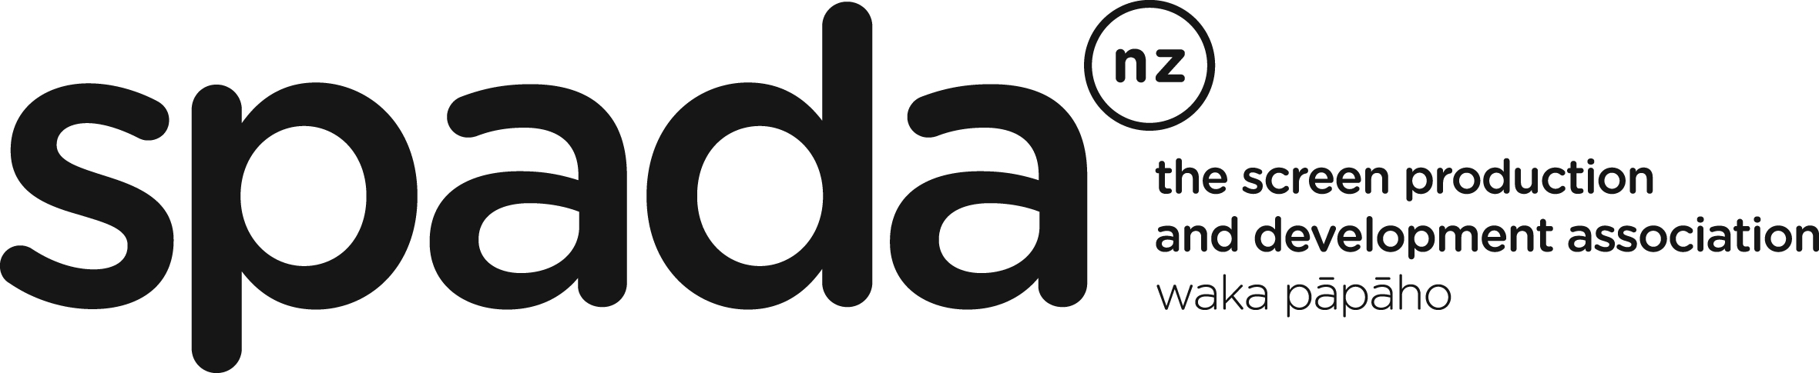
LICENCE AGREEMENT

I,____________________, (name of individual), on behalf ____________________(the Producer), hereby acknowledge receipt of the SPADA Individual Performance Agreement and Backend Agreement (the Agreements), as agreed between the Screen Production and Development Association (SPADA) and New Zealand Actors’ Equity (Equity) effective from 01 December 2024 to 01 December 2025 for use on New Zealand based productions, and state that I am authorized to execute this Licence Agreement on behalf of the Producer.

The Producer hereby acknowledges and warrants that by executing these Agreements:

- it is becoming signatory to the said Agreements and agrees to abide by and conform to all the terms and conditions contained in the Agreements in respect of the production provisionally entitled ___________________(the Production);
- it is only permitted to utilise the Agreements for the named Production only;
- it will not amend or modify the Agreements;
- it will not copy or infringe the intellectual property rights of both SPADA and Equity as copyright owners of the Agreements; and
- it will indemnify both SPADA and Equity against any and all claims, judgments, losses, damages, costs and expenses (including reasonable outside legal costs and expenses) and liabilities and GST and interest in respect of the same suffered or incurred, directly or indirectly, by either of them in consequence of any breach by the Producer of a material term or condition of this Licence Agreement.

Check one of the following.

For Association Members:

 The Producer hereby certifies that it is a Member in Good Standing of the following organization: SPADA: Membership No:

OR

 The Producer hereby certifies that it is a not a Member in Good Standing of SPADA and accordingly is required to pay to SPADA the applicable licence fee (the Fee) as advised and agreed with SPADA for the use of the Agreements. Authorisation to utilise the Agreements will only become effective once SPADA has received payment of the Fee.

It is understood that a copy of this Licence Agreement shall be forwarded to SPADA and Equity.

Dated this day ______________________ of _____________________

Producer:
____________________________ _______________________
(Name) (Phone)/(Email)

Street: ________ ________________________

City: __________________________

Per: _______________________
(Signature)

